Youth National Simulation Comp
Overview & Purpose
To provide Youth Climbing Competitors in Victoria an opportunity to experience a simulated climbing competition to acquire the skills and temperament to compete effectively at a National level. The event will be held and run according to SCA rules and will encompass the three climbing disciplines of Lead Climbing, Bouldering and Speed Climbing. In addition, the event gives climbing gyms around Melbourne an opportunity to host different events.
The simulation will also provide parents and guardians with an understanding of competition formats and the rules and regulations that underpin a competition at a State, National and International level. There is also an opportunity for parents and guardians to develop their skills in judging and belaying commensurate with competition requirements.
The individual events will be held at the climbing gyms described below and it is expected that participants arrive at each venue before the allocated start times to ensure sufficient time for briefing and warming up.

Bayside Rock
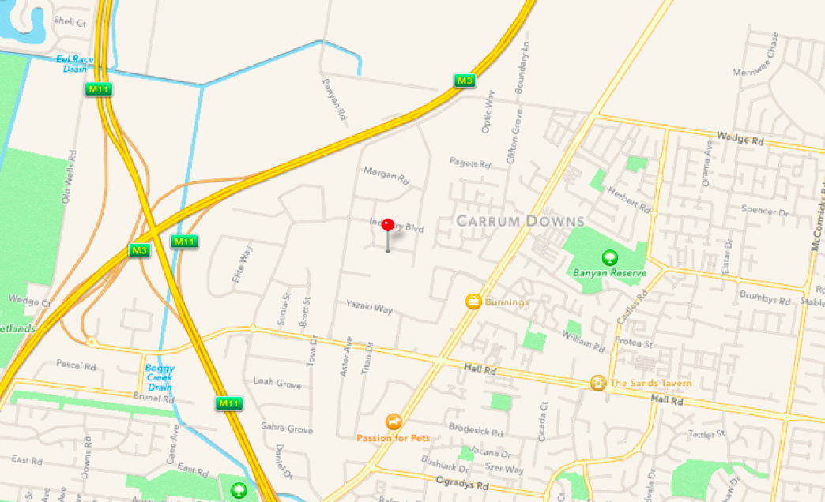
Bayside Rock Climbing
9 Network Drive
Carrum Downs, Victoria 3201
Australia
Date: 5th May 2017
Time: 6 pm
Bring your own food and snacks
Cost: Gym entry to be paid via SCA website. If a YCCV member, payment is included within membership.
Phone: 03

Hardock Nunawading
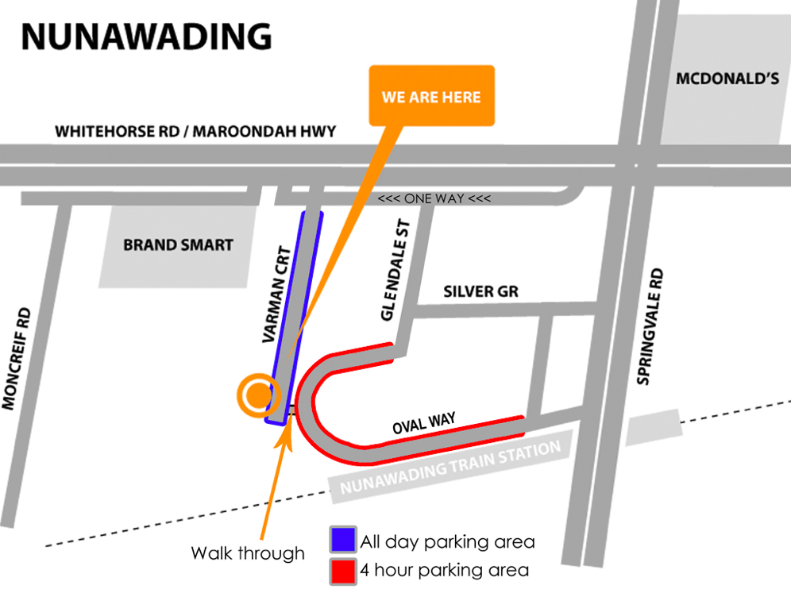
Hardrock Nunawading
16 - 18 Varman Court
Nunawading, Victoria 3131
Australia
Date: 6th May 2017
Time: 9 am
Bring your own food and snacks
Cost: Gym entry to be paid via SCA website. If a YCCV member, payment is included within membership.

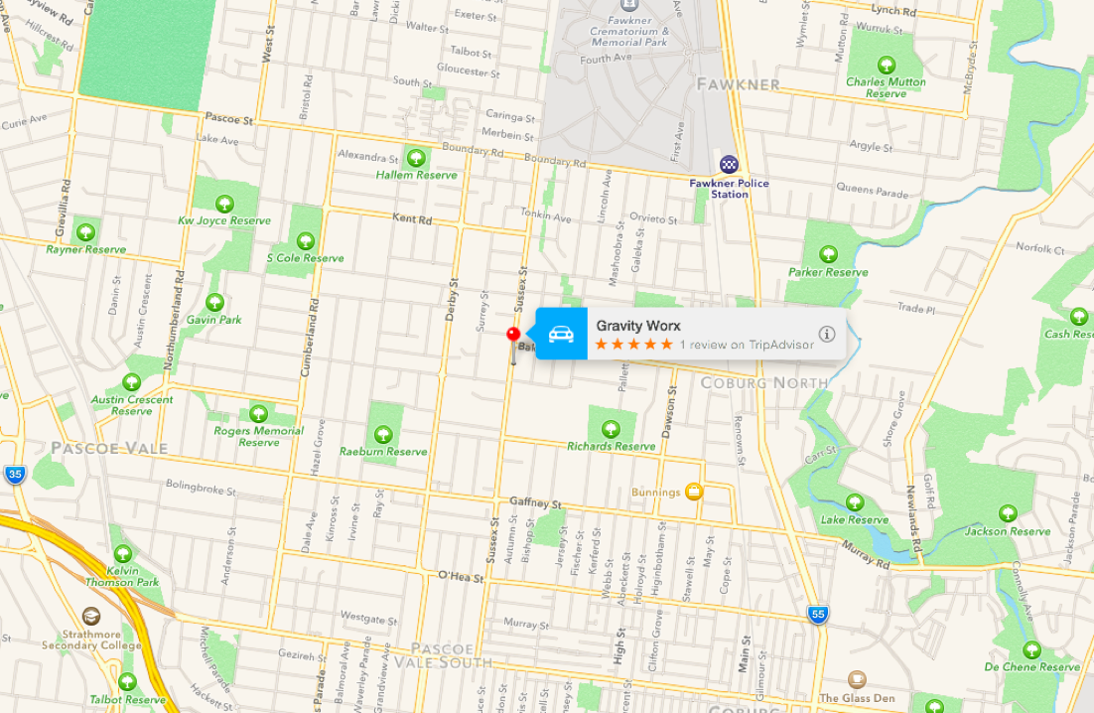
Gravity Worx
Gravity Worx
182-184 Sussex Street
Coburg, Victoria 3058
Australia
Date: 7th May 2017
Time: 10 am
Bring your own food and snacks
Cost: Gym entry to be paid via SCA website. If a YCCV member, payment is included within membership.

Parents and Guardians meeting
· To learn how to judge
· To learn about competition belaying
· To learn about competition organization and format
· Will be held at all three venues
· Contact Ellen on 0403111701

Proposed Timetable: (subject to change)
Friday 5th of May 2017 - 6 pm - Bayside Rock
Date | Day | Time | Venue | Activity | Event
5th May | Friday | 6 pm | Bayside Rock | Warm-up and Briefing | Bouldering
 |  | 6:45 pm |  | Competition begins
 |  | 8:45 pm |  | Competition ends
 |  | 8:45 pm |  | Warm-down and debrief
 |  | 9:45 pm |  | Conclusion of event

Saturday 6th of May 2017 - 9 am - Hardrock Nunawading
Date | Day | Time | Venue | Activity | Event
6^{6h} May | Saturday | 9 am | Hardrock Nunawading | Warm-up and briefing | Lead Climbing
 |  | 9:45 am |  | Competition begins
 |  | 12:15 pm |  | Lunch
 |  | 12:45 pm |  | Competition continues
 |  | 2:15 pm |  | Competition ends
 |  | 2:15 pm |  | Warm down and briefing
 |  | 3:15 pm |  | Conclusion of event
Sunday 7th of May 2017 - 10 am - Gravity Worx
Date | Day | Time | Venue | Activity | Event
7^{6h} May | Sunday | 10 am | Gravity Worx | Warm-up and Briefing | Speed Climbing
 |  | 10:45 am |  | Competition begins
 |  | 12:45 pm |  | Competition ends
 |  | 12:45 pm |  | Warm-down and briefing
 |  | 1:45 pm |  | Conclusion of event

